1. **Over view of server administration**
2. **Introduction**

In computing, a server is any combination of [hardware](http://en.wikipedia.org/wiki/Hardware) or [software](http://en.wikipedia.org/wiki/Software) designed to provide [services](http://en.wikipedia.org/wiki/Service_%28systems_architecture%29) to [clients](http://en.wikipedia.org/wiki/Client_%28computing%29). When used alone, the term typically refers to a [computer](http://en.wikipedia.org/wiki/Computer) which may be running a [server operating system](http://en.wikipedia.org/wiki/Server_operating_system), but is also used to refer to any software or [dedicated hardware](http://en.wikipedia.org/wiki/Computer_appliance) capable of providing services.

## Usage

The *server* is used quite broadly in [information technology](http://en.wikipedia.org/wiki/Information_technology). Despite the many Server branded products available (such as Server editions of Hardware, Software and/or Operating Systems), in theory any computerized process that shares a resource to one or more client processes is a Server. To illustrate this, take the common example of File Sharing. While the existence of files on a machine does not classify it as a server, the mechanism which shares these files to clients by the operating system is the Server.

Similarly, consider a web server application (such as the [multiplatform](http://en.wikipedia.org/wiki/Multiplatform) "[Apache HTTP Server](http://en.wikipedia.org/wiki/Apache_HTTP_Server)"). This web server software can be *run* on any capable [computer](http://en.wikipedia.org/wiki/Computer). For example, while a [laptop](http://en.wikipedia.org/wiki/Laptop) or Personal Computer is not typically known as a server, they can in these situations fulfil the role of one, and hence be labelled as one. It is in this case that the machine's purpose as a [web server](http://en.wikipedia.org/wiki/Web_server) classifies it in general as a Server.

In the hardware sense, the word *server* typically designates computer models intended for running [software applications](http://en.wikipedia.org/wiki/Software_applications) under the heavy demand of a [network](http://en.wikipedia.org/wiki/Computer_network) environment. In this [client–server](http://en.wikipedia.org/wiki/Client%E2%80%93server) configuration one or more machines, either a computer or a [computer appliance](http://en.wikipedia.org/wiki/Computer_appliance), share information with each other with one acting as a [host](http://en.wikipedia.org/wiki/Host_%28network%29) for the other.

While nearly any [personal computer](http://en.wikipedia.org/wiki/Personal_computer) is capable of acting as a network server, a [dedicated server](http://en.wikipedia.org/wiki/Dedicated_server) will contain features making it more suitable for production environments. These features may include a faster [CPU](http://en.wikipedia.org/wiki/Central_processing_unit), increased high-performance [RAM](http://en.wikipedia.org/wiki/RAM), and typically more than one large [hard drive](http://en.wikipedia.org/wiki/Hard_disk_drive). More obvious distinctions include marked [redundancy](http://en.wikipedia.org/wiki/Redundancy_%28engineering%29) in [power supplies](http://en.wikipedia.org/wiki/Power_supply), network connections, and even the servers themselves.

## Server hardware

[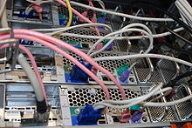](http://en.wikipedia.org/wiki/File:DL380sREAR.jpg)

[Hardware](http://en.wikipedia.org/wiki/Computer_hardware) requirements for servers vary, depending on the server application. Absolute CPU speed is not usually as critical to a server as it is to a desktop machine. Servers' duties to provide service to many users over a network lead to different requirements like fast network connections and high I/O throughput. Since servers are usually accessed over a network they may run in [headless](http://en.wikipedia.org/wiki/Headless_system) mode without a [monitor](http://en.wikipedia.org/wiki/Visual_display_unit) or input device. Processes which are not needed for the server's function are not used. Many servers do not have a [graphical user interface](http://en.wikipedia.org/wiki/Graphical_user_interface) (GUI) as it is unnecessary and consumes resources that could be allocated elsewhere. Similarly, audio and [USB](http://en.wikipedia.org/wiki/Universal_Serial_Bus) interfaces may be omitted.

## Servers on the Internet

Almost the entire structure of the [Internet](http://en.wikipedia.org/wiki/Internet) is based upon a [client–server](http://en.wikipedia.org/wiki/Client%E2%80%93server) model. High-level [root nameservers](http://en.wikipedia.org/wiki/Root_nameserver), [DNS servers](http://en.wikipedia.org/wiki/Domain_Name_System), and routers direct the traffic on the internet. There are millions of servers connected to the Internet, running continuously throughout the world.

Among the many services provided by Internet servers are:

* [World Wide Web](http://en.wikipedia.org/wiki/World_Wide_Web)
* [Domain Name System](http://en.wikipedia.org/wiki/Domain_Name_System)
* [e-mail](http://en.wikipedia.org/wiki/E-mail)
* [FTP file transfer](http://en.wikipedia.org/wiki/File_Transfer_Protocol)
* [chat](http://en.wikipedia.org/wiki/Online_chat) and [instant messaging](http://en.wikipedia.org/wiki/Instant_messaging)
* [voice communication](http://en.wikipedia.org/wiki/Voice_over_Internet_Protocol)
* [streaming audio and video](http://en.wikipedia.org/wiki/Streaming_media)
* [Online gaming](http://en.wikipedia.org/wiki/Online_game)
* [Database servers](http://en.wikipedia.org/wiki/Database_servers)

Virtually every action taken by an ordinary [Internet](http://en.wikipedia.org/wiki/Internet) user requires one or more interactions with one or more servers.

There are also technologies that operate on an [inter-server](http://en.wikipedia.org/wiki/Inter-server) level. Other services do not use dedicated servers; for example [peer-to-peer file sharing](http://en.wikipedia.org/wiki/File_sharing), some implementations of [telephony](http://en.wikipedia.org/wiki/Telephony) (e.g. [Skype](http://en.wikipedia.org/wiki/Skype)), and supplying television programs to several users (e.g. [Kontiki](http://en.wikipedia.org/wiki/Kontiki), [SlingBox](http://en.wikipedia.org/wiki/SlingBox)).

1. **client-server architecture**

Under the structure of the client-server architecture, a business's computer network will have a server computer, which functions as the "brains" of the organization, and a group of client computers, which are commonly called **workstations**. The server part of the client-server architecture will be a large-capacity computer, perhaps even a [mainframe](http://www.wisegeek.com/what-are-mainframes.htm), with a large amount of data and functionality stored on it. The client portions of the client-server architecture are smaller computers that employees use to perform their computer-based responsibilities.

Servers commonly contain data files and applications that can be accessed across the network, by workstations or employee computers. An employee who wants to access company-wide data files, for instance, would use his or her client computer to access the data files on the server. Other employees may use a common-access application by accessing the server through their client computers.

This type of server is called an [***application server***](http://www.wisegeek.com/what-is-an-application-server.htm)**.** It takes full advantage of the client-server architecture by using the server as a storage device for applications and requiring the clients to log in to the server in order to use those applications. Examples of this kind of application are numerous; among the most popular are word processors, [spreadsheets](http://www.wisegeek.com/what-is-a-spreadsheet.htm), and graphic design programs. In each case, the use of the applications illustrates the client-server architecture.

The server is not just for storage, however. Many networks have a client-server architecture in which the server acts as a processing power source as well. In this scenario, the client computers are virtually "plugged in" to the server and gain their processing power from it. In this way, a client computer can simulate the greater processing power of a server without having the requisite processor stored within its framework. Here, the client-server architecture describes a virtual sort of power plant.

Even the World Wide Web is an example of client-server architecture. Each computer that uses a [Web browser](http://www.wisegeek.com/what-is-a-web-browser.htm) is a client, and the data on the various Web pages that those clients access is stored on multiple servers.

1. **Preparation and Installing of Windows Operating System**
2. **Hardware requirements**

Review the table on this page to determine the minimum and recommended system requirements needed to run Windows Server 2003, Standard Edition, Enterprise Edition, Datacenter Edition, and Web Edition.

|  |  |  |  |  |  |  |  |  |  |  |  |  |  |  |  |  |  |  |  |  |  |  |  |  |  |  |  |  |  |  |  |  |  |  |  |  |  |  |  |  |
| --- | --- | --- | --- | --- | --- | --- | --- | --- | --- | --- | --- | --- | --- | --- | --- | --- | --- | --- | --- | --- | --- | --- | --- | --- | --- | --- | --- | --- | --- | --- | --- | --- | --- | --- | --- | --- | --- | --- | --- | --- |
| |  |  |  |  |  | | --- | --- | --- | --- | --- | | **Requirement** | **Standard Edition** | **Enterprise Edition** | **Datacenter Edition** | **Web Edition** | | Minimum CPU Speed | 133 MHz | 133 MHz for x86-based computers  733 MHz for Itanium-based computers* | 400 MHz for x86-based computers  733 MHz for Itanium-based computers* | 133 MHz | | Recommended CPU Speed | 550 MHz | 733 MHz | 733 MHz | 550 MHz | | Minimum RAM | 128 MB | 128 MB | 512 MB | 128 MB | | Recommended Minimum RAM | 256 MB | 256 MB | 1 GB | 256 MB | | Maximum RAM | 4 GB | 32 GB for x86-based computers  512 GB for Itanium-based computers* | 64 GB for x86-based computers  512 GB for Itanium-based computers* | 2 GB | | Multiprocessor Support ** | Up to 4 | Up to 8 | Minimum 8 required  Maximum 64 | Up to 2 | | Disk Space for Setup | 1.5 GB | 1.5 GB for x86-based computers  2.0 GB for Itanium-based computers* | 1.5 GB for x86-based computers  2.0 GB for Itanium-based computers* | 1.5 GB | |

1. **nLite and vLite**

**nLite** and **vLite** are [freeware](http://en.wikipedia.org/wiki/Freeware) [applications](http://en.wikipedia.org/wiki/Application_software) which create customized installation CDs of [Microsoft](http://en.wikipedia.org/wiki/Microsoft) [Windows 2000](http://en.wikipedia.org/wiki/Windows_2000), [Windows XP](http://en.wikipedia.org/wiki/Windows_XP), [Windows Server 2003](http://en.wikipedia.org/wiki/Windows_Server_2003) and [Windows Vista](http://en.wikipedia.org/wiki/Windows_Vista). nLite lets users customize and remove components from their Windows installation disc, integrate update packages and automate the installation process by entering product key, administrator's password and regional settings beforehand or install third party programs automatically. nLite supports [Windows 2000](http://en.wikipedia.org/wiki/Windows_2000), [Windows XP](http://en.wikipedia.org/wiki/Windows_XP), [Windows Server 2003](http://en.wikipedia.org/wiki/Windows_Server_2003) while vLite is made for [Windows Vista](http://en.wikipedia.org/wiki/Windows_Vista).

# Workgroup and Domain

# What is the difference between a domain and a workgroup?

Computers on a network can be part of a workgroup or a domain. The main difference between workgroups and domains is how resources on the network are managed. Computers on home networks are usually part of a workgroup, and computers on workplace networks are usually part of a domain.

## In a workgroup:

* All computers are peers; no computer has control over another computer.
* Each computer has a set of user accounts. To use any computer in the workgroup, you must have an account on that computer.
* There are typically no more than ten to twenty computers.
* All computers must be on the same local network or subnet.

## In a domain:

* One or more computers are servers. Network administrators use servers to control the security and permissions for all computers on the domain. This makes it easy to make changes because the changes are automatically made to all computers.
* If you have a user account on the domain, you can log on to any computer on the domain without needing an account on that computer.
* There can be hundreds or thousands of computers.
* The computers can be on different local networks.

1. **Windows 2003 Active Directory Domain**
   1. **What is OS?**

The operating system is actually what makes a computer useable.

It handles the files and folders, the devices installed on the computer and the external devices connected to the computer.

Any application you run is managed by the operating system. If your application wants to use the printer.

The operating system tells your application (a word processor says) which printers are available (if any). When you print the document, the operating system ensures the print data gets to the printer.

* 1. **What is a server?**

In information technology, a server is a computer [program](http://searchsoftwarequality.techtarget.com/sDefinition/0,,sid92_gci212834,00.html) that provides services to other computer programs (and their users) in the same or other computers.

Operating System Type:

There are different types of OS and they are mostly broken into to two groups: Client and Server

|  |  |
| --- | --- |
| Client | Server |
| [Windows 95](http://www.techeez.com/novice_info/differences_between_operating_sy.htm#Windows 95/98/ME#Windows 95/98/ME) | [Linux/Unix](http://www.techeez.com/novice_info/differences_between_operating_sy.htm#Windows NT4 Server/2000 Server/Any Linux/Unix Flavors#Windows NT4 Server/2000 Server/Any Linux/Unix Flavors) |
| [Windows 98](http://www.techeez.com/novice_info/differences_between_operating_sy.htm#Windows 95/98/ME#Windows 95/98/ME) | [Windows NT4 Server](http://www.techeez.com/novice_info/differences_between_operating_sy.htm#Windows NT4 Server/2000 Server/Any Linux/Unix Flavors#Windows NT4 Server/2000 Server/Any Linux/Unix Flavors) |
| [Windows ME](http://www.techeez.com/novice_info/differences_between_operating_sy.htm#Windows 95/98/ME#Windows 95/98/ME) | [Windows 2000 Server](http://www.techeez.com/novice_info/differences_between_operating_sy.htm#Windows NT4 Server/2000 Server/Any Linux/Unix Flavors#Windows NT4 Server/2000 Server/Any Linux/Unix Flavors) |
| [Windows NT workstation](http://www.techeez.com/novice_info/differences_between_operating_sy.htm#Windows NT4 Workstation/2000 Professional#Windows NT4 Workstation/2000 Professional) | [Windows 2003 Server](http://www.techeez.com/novice_info/differences_between_operating_sy.htm#Windows NT4 Server/2000 Server/Any Linux/Unix Flavors#Windows NT4 Server/2000 Server/Any Linux/Unix Flavors) |
| [Windows 2000 Professional](http://www.techeez.com/novice_info/differences_between_operating_sy.htm#Windows NT4 Workstation/2000 Professional#Windows NT4 Workstation/2000 Professional) | [Windows 2008 Server](http://www.techeez.com/novice_info/differences_between_operating_sy.htm#Windows NT4 Server/2000 Server/Any Linux/Unix Flavors#Windows NT4 Server/2000 Server/Any Linux/Unix Flavors) |
| Linux X windows |  |
| And many more |  |
| [Windows XP](http://www.techeez.com/novice_info/differences_between_operating_sy.htm#Windows NT4 Workstation/2000 Professional#Windows NT4 Workstation/2000 Professional) |  |
| Vista |  |
| Windows 7 |  |

* 1. **What is Domain?**

A collection of computers & servers that are part of the same centralized database.

**Many domains are available like:**

Single Domain, Parent Domain, Child Domain, Domain tree, and Forest domain.

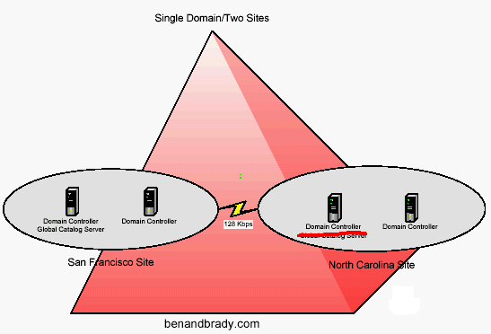

* **Parent domain** - One domain above another in a domain tree.

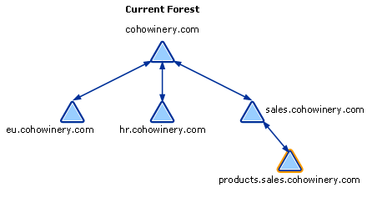

* **Child domain** - One domain below another in a domain tree. The child inherits the domain name of its parent in a DNS hierarchical naming convention. Example: "sales.cohowinery.com

# What is a domain tree?

In Windows 2003, a domain can be a child of another domain (e.g., sales.cohowinery.com is a child of cohowinery.com). A child domain name always includes the complete parent domain name. A child domain and its parent share a two-way transitive trust.

A domain tree exists when one domain is the child of another domain that we called Domain tree. A domain tree must have a **contiguous names pace**.

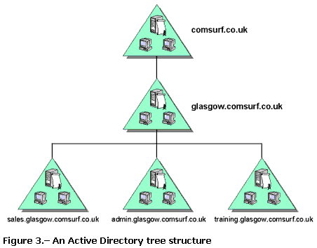

# What is a domain forest?

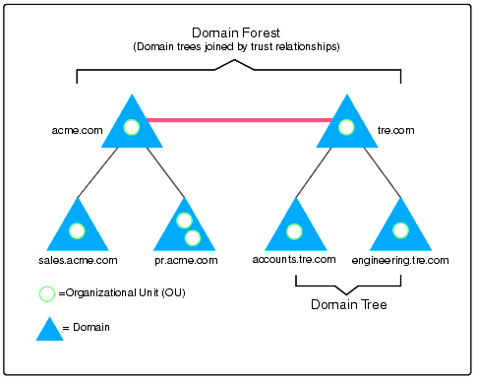

You might have several domain trees in your organization that you need to share resources. To solve this problem, you can join the trees to form a forest.

**A forest is a collection of trees** that don’t necessarily form a contiguous namespace (although each tree must be contiguous).

1. Active Directory Domains
   1. **Domains**

A collection of computers & servers that are part of the same centralized database.

* 1. **Purposes Of Active Directory:**

1. Centralized User/Group Authentication – the ability to log on one time and access resources throughout the domain.
2. Centralized Security – the ability to control the user/computer environment, from one computer, across the whole network using Group Policy.
3. Network resources are easy to find. (Searchable Database of resources including users, computers, shared folders, printers and more.)
4. Very scaleable – small companies and large companies.
5. Flexibility with the ability to add new classes, attributes, and objects.
6. Extensibility

### Parts and Structure:

The domain is the core unit in the Active Directory structure. Active Directory includes:

* A **database** of information about network users and resources.
* A **service** managing the database.

Active directory is organized hierarchically and contains information about:

* User & Group Accounts
* Computers
* Shared folders
* Printers
  1. **Active Directory:**

The name for Microsoft’s directory service, similar to Novell’s NDS.

-Dcpromo.exe is used to install Active Directory onto a server 2003 computer

-Installing Active Directory on a server 2003 computer turns it into a **domain controller**

-Creates a file named **NTDS.DIT, which is the Active Directory Database**

-Disables the local Users/Groups tool. Users/Groups are created in AD Users and Computers

Requirements:

1. Server 2003 CD
2. NTFS partition
3. NIC Plugged into a network
4. TCP/IP Configured properly
5. DNS Configured Properly
   1. **Active Directory Database**

**Active Directory Database Files:**

**Note: It’s located in c:\windows\NTDS**

-Active Directory's database engine is the Extensible Storage Engine (ESE)

- The ESE has the capability to grow to 16 terabytes which would be large enough for 10 million objects.

1. NTDS.DIT (New Technology Directory Service. Directory Information Tree)
2. edb.chk (Engine database. checkpoint)
3. edb.log (transaction. Log)
4. Edbxxxxx.log – transaction logs.
5. res1.log (Reserved Log file)
6. res2.log (Reserved Log file)
7. temp.edb

**Ntds.dit** grows as the database fills up. However, the logs are of fixed size (10 MB). Any change made to the database is also appended to the current log file.

**Edb.log** is the current log file. When a change is made to the database, it is written to the Edb.log file. When the Edb.log file is full of transactions, it is renamed to Edbxxxxx.log. (It starts at 00001 and continues to increment using hexadecimal notation.) Since Active Directory uses circular logging, old log files are constantly deleted, once they have been written to the database. At any point, you will find the edb.log file, and maybe one or more Edbxxxxx.log files.

**Res1.log** and **Res2.log** are "placeholders" — designed to reserve (in this case) the last 20 MB of disk space on this drive. This is designed to give the log files sufficient room for a graceful shutdown if all other disk space is consumed.

The **Edb.chk** file, stores the database checkpoint, which identifies the point where the database engine needs to replay the logs.

**Temp.edb** contains information on the transactions that are being processed.

### System Volume (SYSVOL):

SYSVOL stores and replicates Group Policy Objects (GPO's), and scripts. As the network grows, SYSVOL can begin to require substantial storage space.

Active Directory _ New Features in Server 2003

1. Rename the Domain (using random.exe & gpfixup.exe)

2. Rename Domain Controllers

3. Modify common properties for multiple users at once. Use the shift & control key

4. Drag and Drop AD objects within the AD users and computers tool

5. Ability to disable the default administrator account

6. Universal Group Membership Caching (cutting down on the need for GCs)

7. Cross Forest Trusts

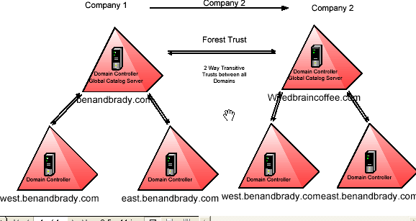

8 . Group Policy Management Console

* 1. **Active Directory – Important terms**

1 .Global Catalog Servers

2 .Universal Group Membership

3 .Universal Principal Names

4 . Schema

5 . FSMO Roles

6 . Functional Levels

**Global Catalog Servers:**

Note: GC is introduced in 2000 and 2003 server.

**What are they ?**

-Special domain controllers in windows 2000 & 2003 server that store partial Active Directory Object information from all domains in a forest.

-Global catalog servers save on bandwidth and result in domain logins and queries becoming more efficient.

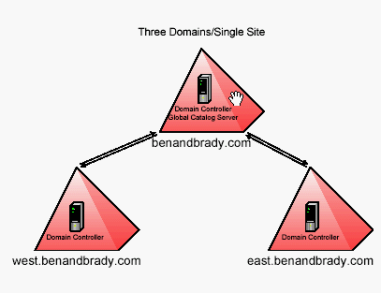

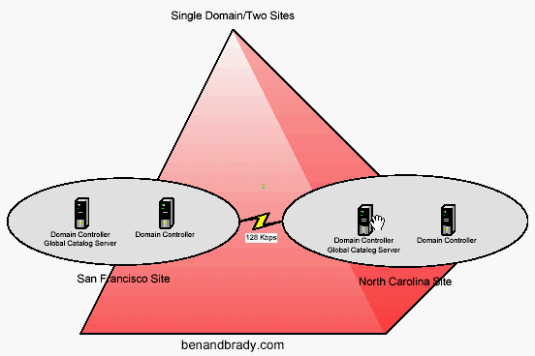

**How are they installed?**

-The first GC is automatically installed on the first domain controller in the domain/forest.



-Additional GC’s are installed through Active Directory sites and Services

-GC server One per site

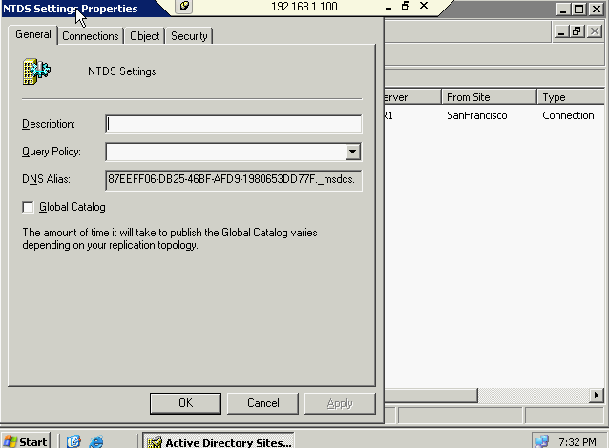

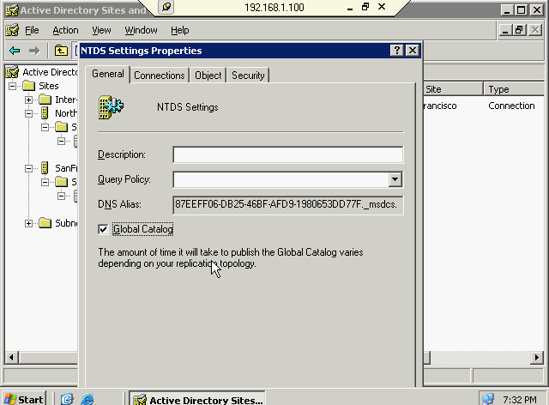

**What are their main functions?**

1. The global catalog server provides universal group information for the user account that is initiating the logon.

2. It allows directory objects to be searched for within the entire forest, not just the domain.

3. Critical to proper Exchange Server functioning.

**Technical Details:**

* A global catalog server is required (in most cases) to logon to the network.
* A global catalog server is not required when a domain administrator logs on
* Cached credentials are used to logon to the local machine only, if a GC is not available.

Universal Group Membership Caching:



-New feature in Server 2003 that allows you to reduce the number of necessary global catalog servers

-A DC in a branch office site will contact a Global Catalog Server and cache the user’s universal group information (including the UPN). Subsequent lognos (after the first) will be handled locally instead of passing over a WAN link.

-Universal Group Membership Caching is not turned on by default

-Enabled at the site level. Once enabled, UGMC will apply to all domain controllers in the site.

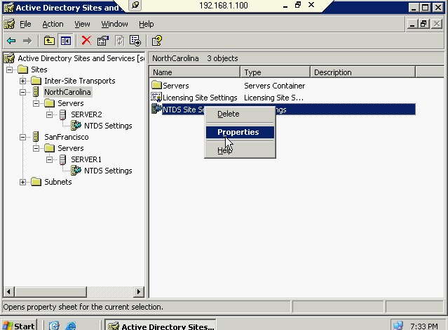

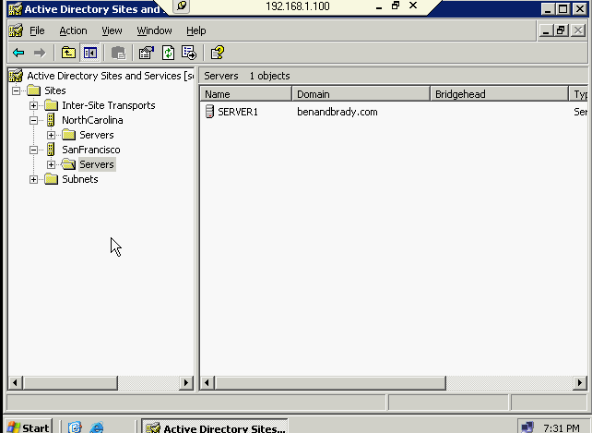

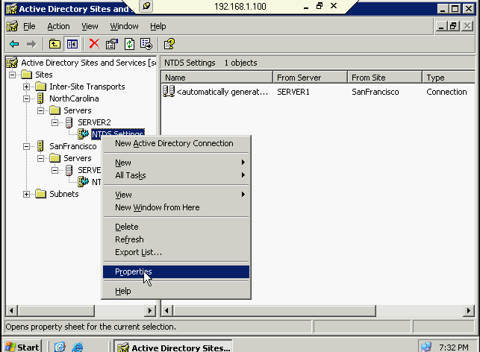

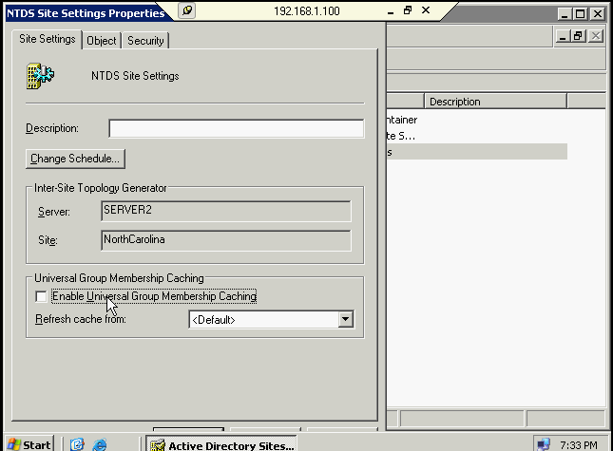

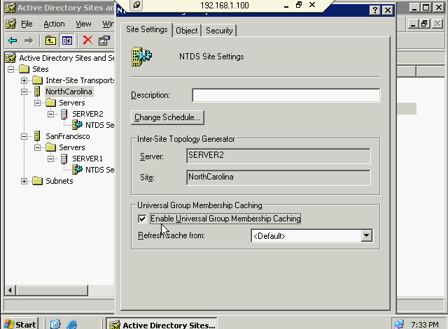

**Universal Principal Names (UPNs) :**

-Used to simplify the logon process

Normal login:

* Username
* Password
* Domain Name or Local Computer

Example --- username – fabrick Log on to---kct.local

Logon using a UPN Name:

Example---username [–fabrick@kct.local](mailto:–fabrick@kct.local) Log on to : not Available (grayed out)

-UPN name in the domain name by default (i.e.kct.local)

-Additional UPN names can be specified in Active Directory, which can be used by anyone in the forest.

-UPN names can be added through Active Directory Domains and Trusts

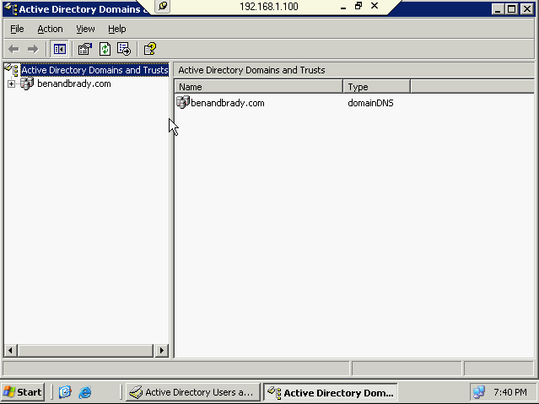

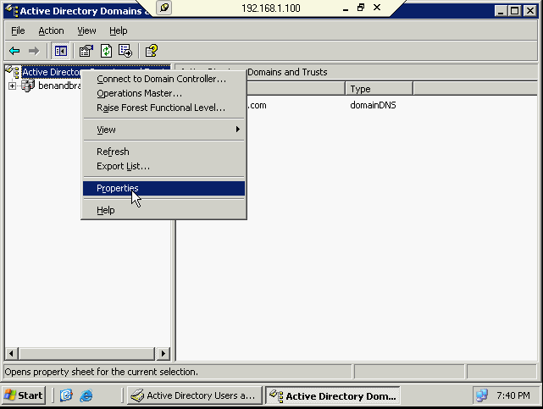

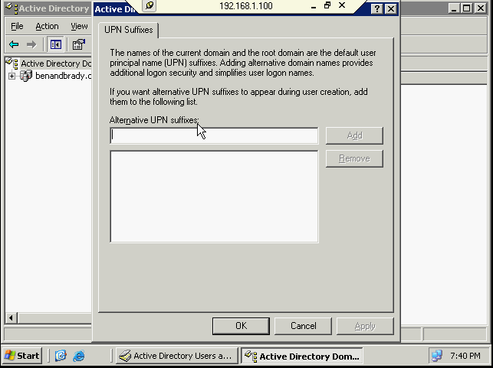

Schema:

-The schema defines the types of projects that can be created within Active Directory and also the kinds of attributes that each object can have

**Object classes** – Objects that can be created within Active Directory (i.e. Users, computers, shared folders, etc..). Each object class has a common set of attributes.

**Attributes** – the information that can be defined about an object (i.e. a user object contains the first name, last name, phone number attributes, just to name a few).

The schema is extensible, meaning it can be changed or modified. You can define additional objects or attributes. Typically schema changes take place when you install Directory Enabled Applications, Such as Exchange Server.

-The schema is modified using the Active Directory Schema snap-in. By default schema you can’t see it ,if you want you should enable it in registry using the command name called **regsvr32 schmmgmt.dll**

**Flexible Single Master Operations (FSMO) Roles:**

**Forest Wide FSMO Roles – One per Forest**

**Schema Master** – Only read/write copy of the schema. All schema changes must be performed on this one DC.

**Domain Naming Master** – Responsible for ensuring unique domain names throughout the forest.

**Domain Wide FSMO Roles – One per domain**

**PDC (Primary Domain Controller) Emulator –** Responsible for replication between NT 4.0 domain controllers. Also synchs time within the domain.

**RID (Relative ID) Master** – Ensures that each object (i.e. users and computers, etc.) within the domain receives a unique ID number.

**Infrastructure Master** – Maintains universal group membership with the different domains in the forest.

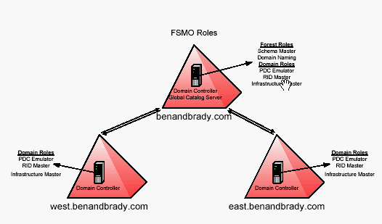

**How to transfer schema from DC to other DC:**

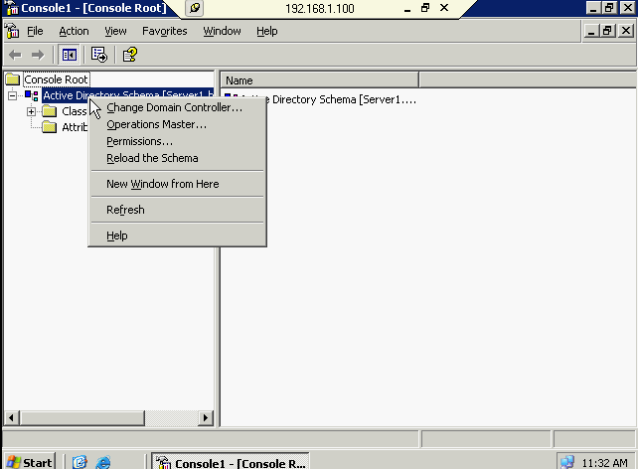

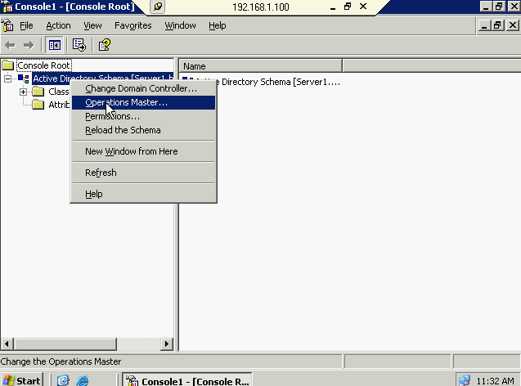

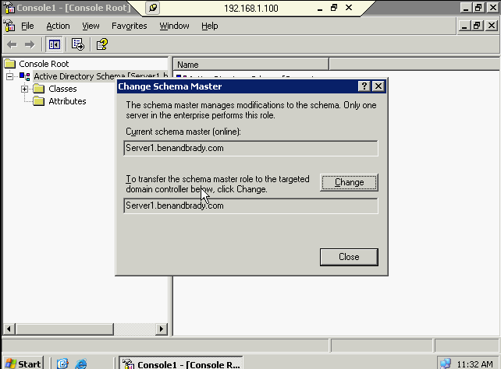

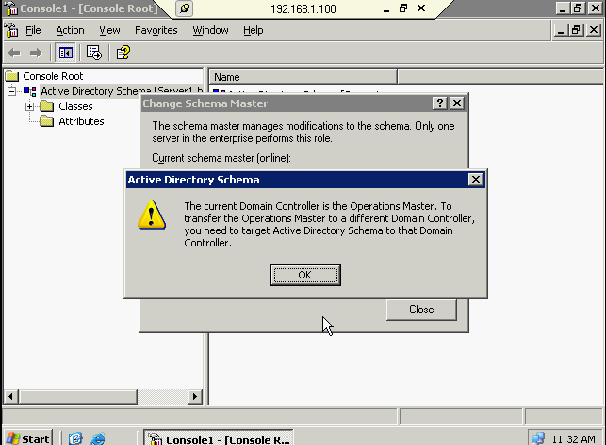

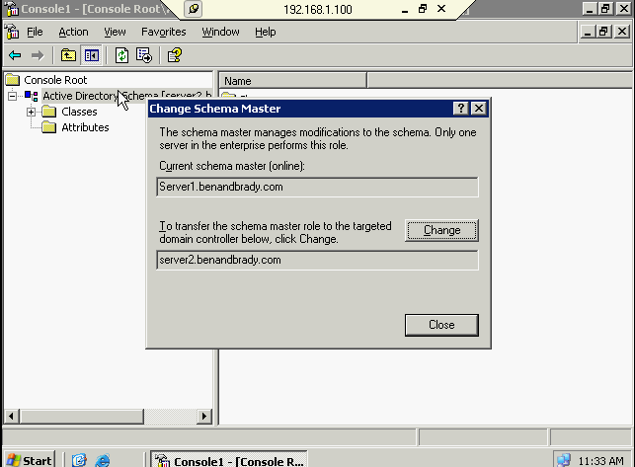

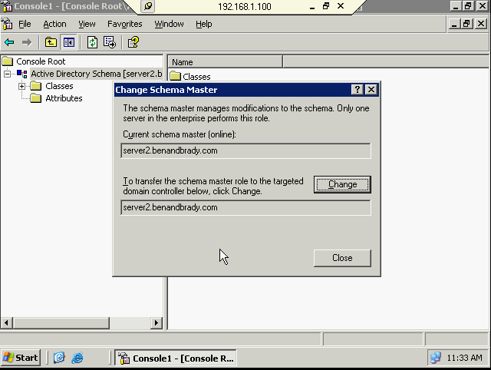

**How to transfer Domain name service**

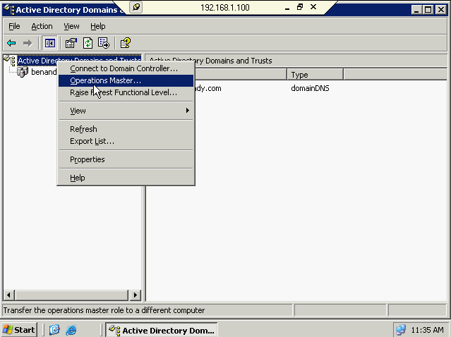

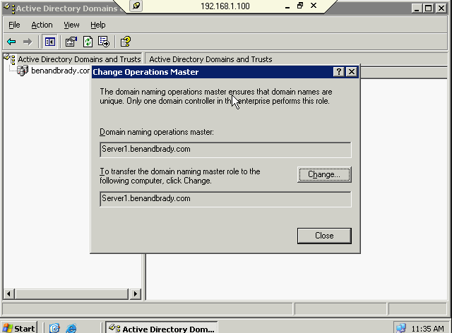

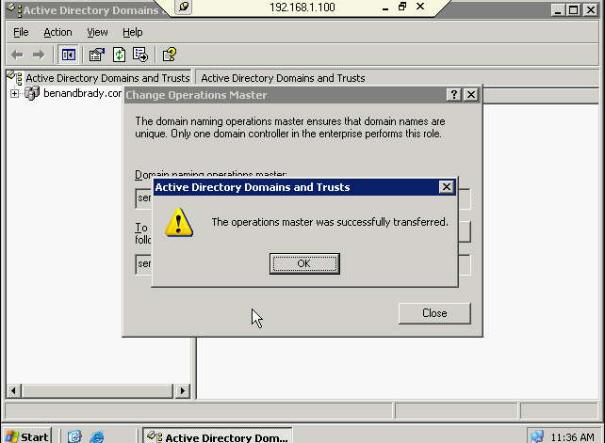

**How to transfer domain roles like PDCE, RID, & INFRASTRUCTURE**

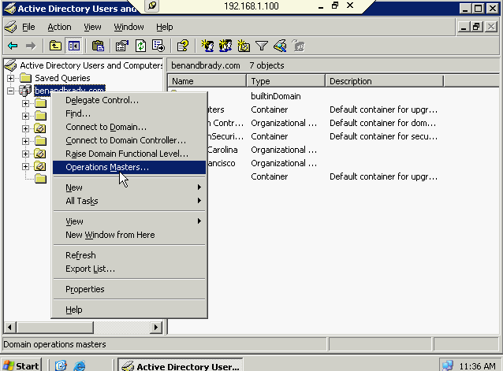

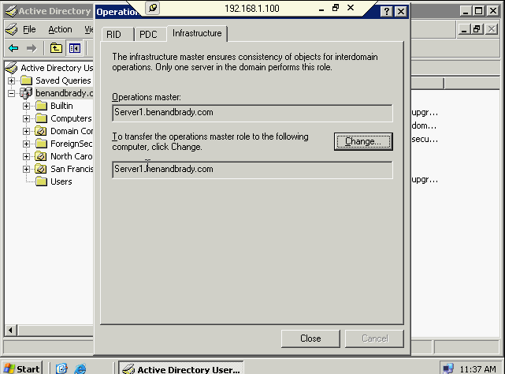

Note: When your schema server or other FSMO server fail, you can’t transfer role, that case you should use low level utility called seize.

Active Directory Partition

The server 2003 Active Directory is partitioned in four distinct parts (2000 in three):

1. Schema Partition (its contained objects and attributes)
2. Configuration Partition (what domain and what naming structure in the forest)
3. Domain Partition (This is the main partition in the Active directory its contained users, groups, printers and etc…)
4. Application Directory Partition (New in 2003) (Application specific information like Directory enabled application such as Exchange mail server application and other Microsoft software)

**Domain controllers have the responsibility of replicating:**

1. Schema Partition (only one schema partition is allowed in one forest and schema partition information is replicating to all three domains)
2. Configuration Partition (Domain naming structure configuration in entire forest)
3. Domain Partition for the local domain (Domain partition information it will not pass it to different domain controller but when you have two domain controller in one domain it will pass)
4. Application Directory Partition ( Only on some 2003 DCs) (you have the choice to choose the Active directory domain for exchange the application directory partition).

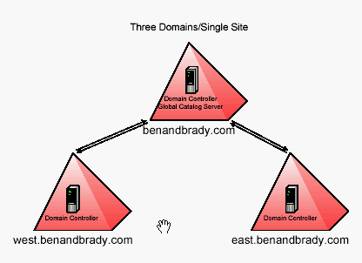

**Global Catalog servers have the responsibility of replicating:**

1. Schema Partition
2. Configuration Partition
3. Domain Partition for the local domain
4. A subset of the properties (partial replica ) for all directory objects in the forest (replicated between global catalog servers only)
5. Global catalog servers do not replicate the Application Directory Partition (they can be configured to do so)

**Functional Levels:**

-Called modes in Windows 2000 (mixed and native)

-Server 2003 features “Domain” and “Forest” Functional Levels

**Domain Functional Levels:**

1. **Windows 2000 Mixed** – the default level, offers very limited features of Active Directory from 2000 or 2003. Supports NT4.0, windows 2000 server & 2003 DCs
2. **Windows 2000 Native**- Supports Windows 2000 & server 2003 DCs. New AD features in 2000 are supported (but not server 2003 feature). This is the default level if you upgrade a window 2000 DC to Server 2003
3. **Windows Server 2003 Interim** – Special level used to upgrade NT 4 DCs to 2003. 2000 DCs are not supported. Same limitations as mixed functional level.
4. **Windows Server 2003** – the highest functional level. Only supports server 2003 DCs. Allows for all of the new domain features in 2003 to work.

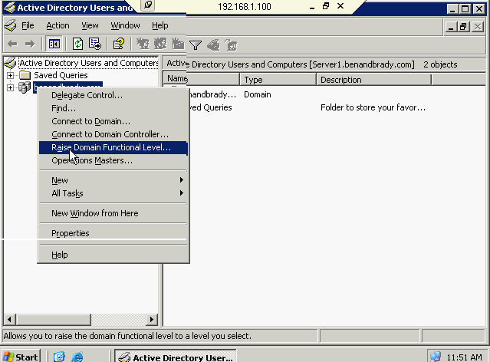

**Forest Functional Levels:**

1. Windows 2000 – the default level, NT4, 2000 & 2003 DCs are all supported.Most of the new AD features in 2003 are disabled.
2. Windows server 2003 Interim – Special level used to upgrade NT 4 DCs to 2003. 2000 DCs are not supported.
3. Windows server 2003 – supports all of the new Server 2003 Active Directory Features.

-All DCs in all domains must be at windows 2000 Native Mode or higher

-Raising the forest functional level all domains to Server 2003 domain functional level.

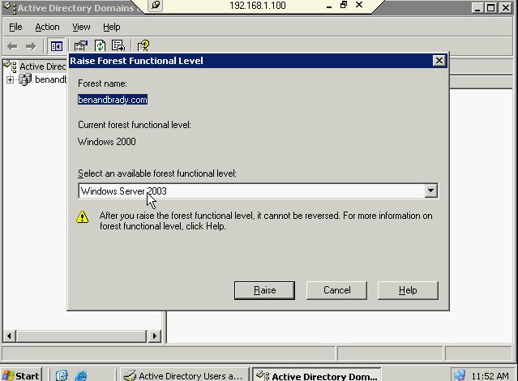

**Server 2003 Features Available (only in Server 2003 Forest function level):**

* Domain Controller renaming
* Domain renaming & reorganizing
* Improved AD replication
* Improved GC replication